**4 и 5 года обучения**

**Задание:** прочитать текст опираясь на аудио приложение, сделать письменный перевод, дать письменный ответ на вопросы. Не забудьте посмотреть достопримечательности Лондона (фото прилагаются к заданию).

**Great Britain**

Great Britain is much smaller than Russia. It is on the British Isles. In Great Britain there are no high mountains, no long rivers and no big forests but there are many large towns. The capital of Great Britain is London. Almost all people speak English there.

The countryside is green all the year round. Very little snow falls in Great Britain but there is much rain. There are many sunny days in May, June, July and August. The south of the country is very beautiful. You can see many flowers in front of the houses there.

Isles-острова, high-высокий, capital-столица, almost-почти, countryside-сельская местность, south-юг.

1. Is Great Britain a big country?
2. Are there high mountains and long rivers in this country?
3. What is the capital of Great Britain?
4. How much snow falls in Great Britain?
5. Does it rain often there?
6. Does it rain often there?
7. What can you see in front of the houses in the south of the country?

**London**

London is the capital of Great Britain. It is a very old city. It was founded by Romans more than two thousand years ago. First it was a small town on the banks of the river Thames(Темза). London was destroyed many times.

Now London is a beautiful city. There are many interesting places in it. The Tower of London(Тауэр) is an old fortress, now it is a big museum. Everybody knows about Big Ben, London Bridge, Saint Paul’s Cathedral(Собор Святого Павла), Westminster Abbey(Вестминстерское Аббатство) and the Buckingham Palace(Букингемский дворец).

found-основывать, thousand-тысяча, first- сначала (первый), ago-назад, bank- берег(банк), destroy-разрушать, many times-много раз, fortress-крепость.

1.What is the capital of Great Britain?

2.How old is London?

3. Who founded this city?

4. What river is London situated (расположился) on?

5. What kind of city is London now?

6. What do you know about the Tower of London?

7. What interesting places in London do you know?

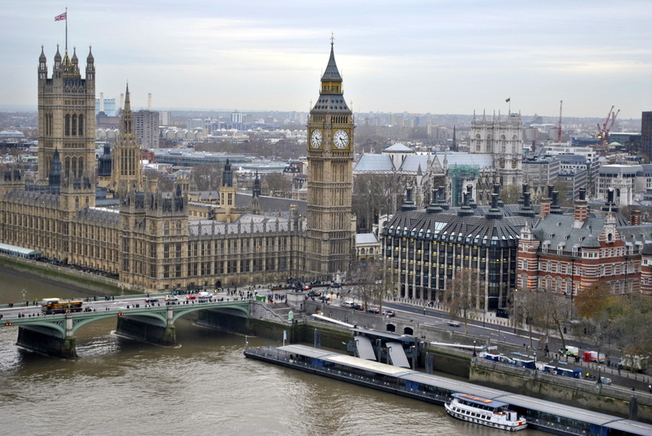

Биг Бэн

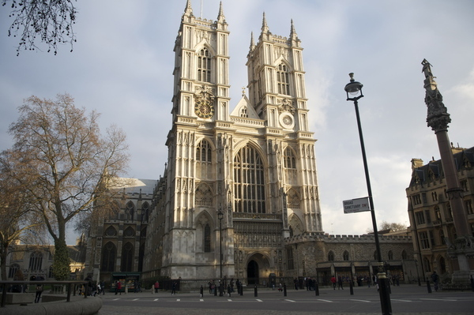

Вестминстерское Аббатство

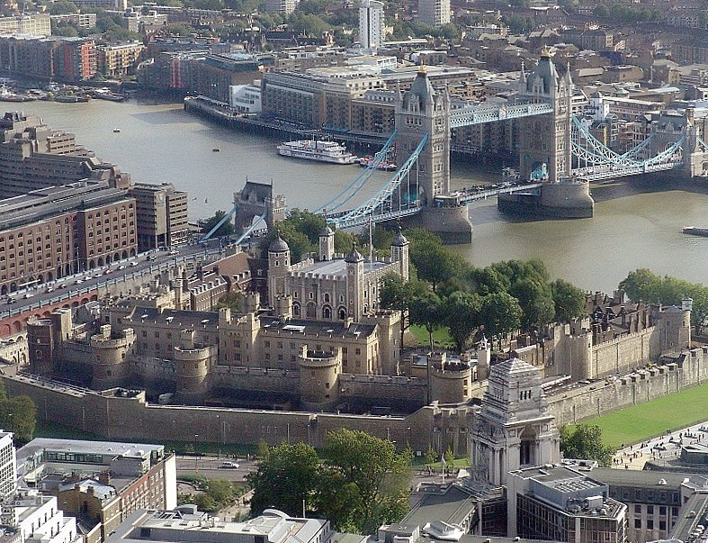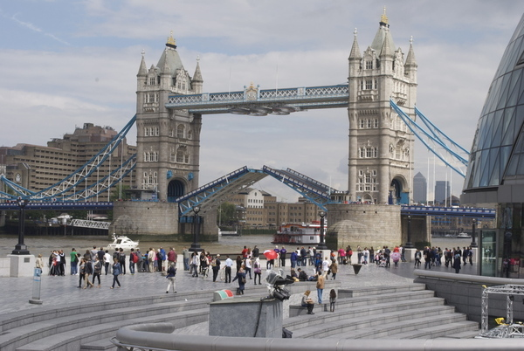

Тауэр и Мост

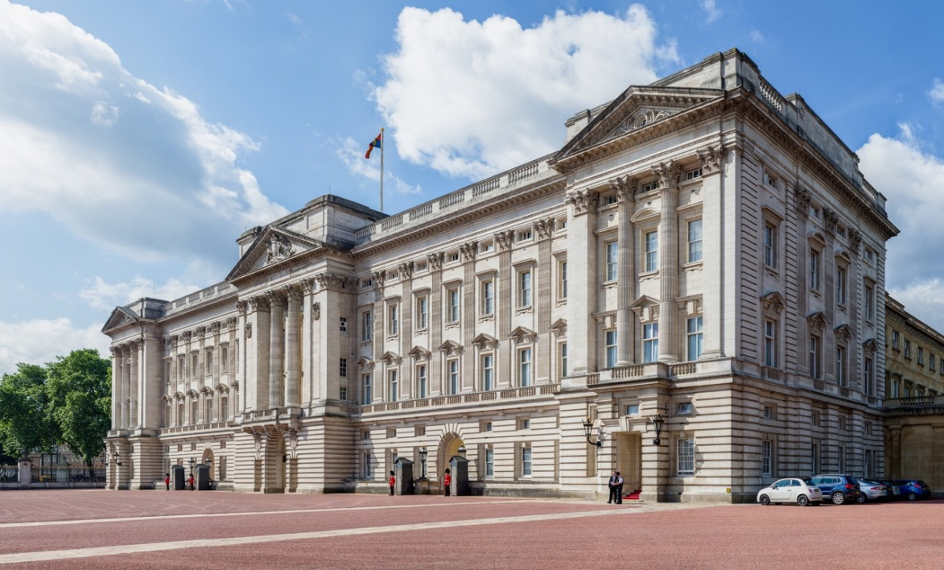

Букингемский дворец

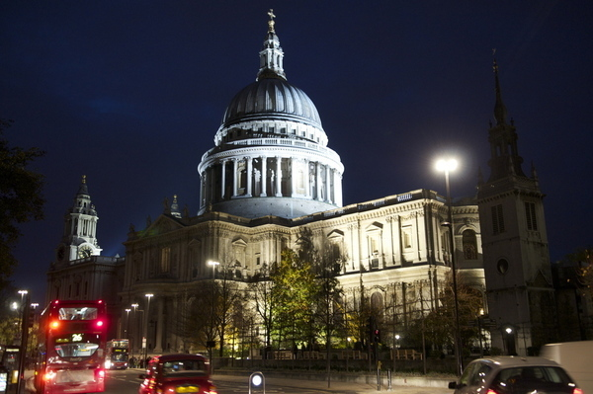

Собор Святого Павла