4 год обучения 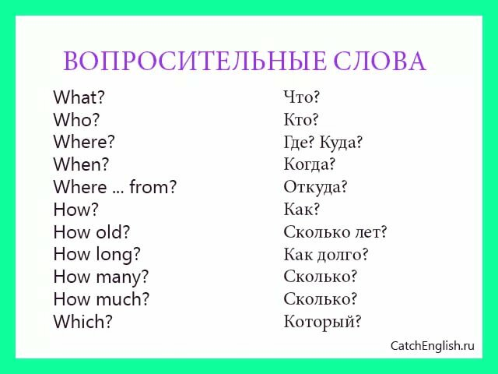
Вставьте вопросительные слова: what, where or when.
- _____ does Molly get up? – At 10 o'clock.
- _____ does Molly have lunch? – At school.
- _____ does Molly read in the morning? – A book.
- _____ do Molly’s parents get home? – At 6 o'clock.
- _____ does Molly’s family have dinner? – At home.
- _____ does Molly do after dinner? – She brushes her teeth.
Вставьте вопросительные слова: how many, where, what, when or how old.
- ________is your school number? – Number 96
- ________ is your school? – 45 years old.
- ________lessons do you have on Friday? – Five.
- ________ is your last lesson on Monday? – English.
- ________do you play sports games? In the gym.
- ________ children are there in your class? -26.

Подберите к каждому вопросительному слову подходящий ответ.
- What? a. Last summer
- Why? b. George
- When? c.He is 18.
- Where? d. $ 16.99
- Which? e. Because I don’t have a car.
- How? f. Once a month.
- How much? g. In Sochi.
- How old? h. The green one.
- How often? i. A cup of coffee.
- Who? j. By train.

