3 год обучения
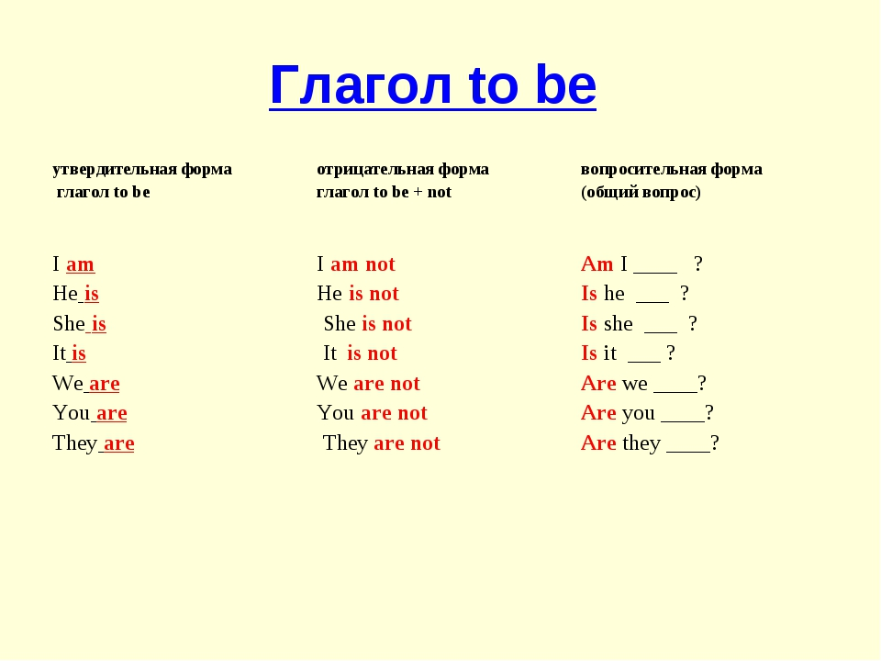
Ex.1 Вставьте am, is, are. Предложения переведите.
1. It … an elephant. 2. Fred … not angry. 3. My friend … kind. 4. Her name … Mary. 5. She … a nice girl. 6. We … pupils. 7. His name … Tom. 8. I … seven. 9. Rex … brave and kind. 10. They … friends. 11. You … happy. 12. Her name … Bess. 13. She … nice. 14. Kate … not lazy. 15. Her name … Jill. 16. She … seven. 17. He … a nice boy. 18. His dress… nice. 19. Tim … sad. 20. He … happy. 21. She and Tom … friends. 22. Nick … strong. 23. Tom … astudent. 24. Mr Green … nice. 25. His pet … funny. 26. Bob … strong. 27. It … black. 28. I … a pupil. 29. My friend … brave. 30. You … sad. 31. They … strong. 32. Pete … nine. 33. Our cat … five. 34. She … seven. 35. They … ten. 36. My name … Kate. 37. I … six. 38. I … not a pupil. 39. My dog … grey. 40. His cat … black and white. 41. My pets … funny. 42. I … Dino. 43. My friend … strong. 44. Billy … fat. 45. We … in the park. 46. Crocodiles … green. 47. Her shorts… dirty. 48. I … not big. 49. Dan … not a teacher. 50. Pupils … lazy. 51. Tony … kind and funny. 52. I … seven. 53. You … a pupil. 54. Tom’s birthday … on the 8th of May. 55. Tom … fromLondon. 56. My pets … funny.

